Presentation Event: The Future of Work 2040 –
Scenario Project Updated
Date: October 29th, 2025
Location: Dan Panorama Hotel, Kaufmann str. 10, Tel Aviv

Background and Aim of the Project: Opening Remarks by Dr. Roby Nathanson, General Director of the Macro Center for Political Economics
The First Scenario Project, 2016-2017
The scenario project was conducted in Israel for the first time in 2016 by the Macro Center for Political Economics, with the cooperation of the Hans-Böckler-Foundation (HBS), and aimed to outline how the world of labor might look in 2040. A survey was conducted among relevant stakeholders, and based on their insights, two key axes that formed the basis for four distinct scenarios were defined:
- Labor Market Configuration, moving from rigidity to flexibility.
- Working Relations, moving from cooperation to conflict.
The Current Scenario Project, 2023-2024
Significant developments in recent years — including breakthroughs in artificial intelligence (AI), the rise of the platform economy, and the COVID-19 pandemic — underscored the need to reassess current trends and gather fresh insights. In the current cycle, stakeholder input led to the identification of two new analytical axes:
- Fragmentation vs. Integration, which details the level of market interconnectedness.
- Domination vs. Self-Determination, which details the degree of worker autonomy.
Together, these axes form the foundation for four distinct future scenarios.

What are Scenarios? Why Scenarios? Presentation by Dr. Stefan Lücking, Hans-Böckler-Foundation
There are multiple possible future trajectories, and given the inherent uncertainty, scenario planning provides a structured way to explore potential outcomes and prepare for them. Scenarios allow us to explore and compare alternative futures, identify a preferred direction, and consider the actions needed to make that future more attainable. The scenarios also enable us to prepare ourselves for the possible futures, even for the ones that are less desired. Hans-Böckler-Foundation research, conducted ten years ago, has found four distinct scenarios that differ by the extent of participation and individualism:
- Peak Performance, in which digitalization is promoted to boost productivity and competitiveness.
- Self-Actualization, in which digitalization contributes to individual creative freedom, flexibility, and variety in the world of work, and includes government standards ensuring participation and a balanced distribution of digitalization and preventing abuses of power.
- Reset, in which digitalization and automation lead to a dramatic loss of jobs and to the proliferation of precarious and inhuman working conditions.
- Cohesion, in which digitalism is taking place and embedded in collective negotiation processes and democratic corporate structures.

The Future of Work 2040 Updated: Presentation of 4 Scenarios by Rita Goldstein-Galperin
How do we make scenarios practical? Although theoretical, the scenarios can constitute a base for drafting general recommendations regarding different market players and stakeholders, thus adding a practical aspect to the concept of scenarios.
There are different types of futures, which differ in their level of possibility to exist and how different they are from the current reality. The four types of futures:
- Possible Future – All conceivable events, limited only by the laws of physics and our imagination.
- Plausible Future – Futures that could happen based on our current understanding of how the world works.
- Probable Future – Futures that are likely to happen based on current trends and trajectories.
- Preferable Future - Futures that we want to happen, reflecting our values and aspirations. We need to think – what is the preferable future? And how can we make it happen?
The objective of the Israeli scenario project was not to compare Israel and Germany directly, but rather to develop broader global insights.
To create different scenarios, two driving powers are chosen, which in the current scenario project were Fragmentation vs. Integration and Domination vs. Self-Determination. From these two powers, it is possible to extract four distinct scenarios, which in our case were:
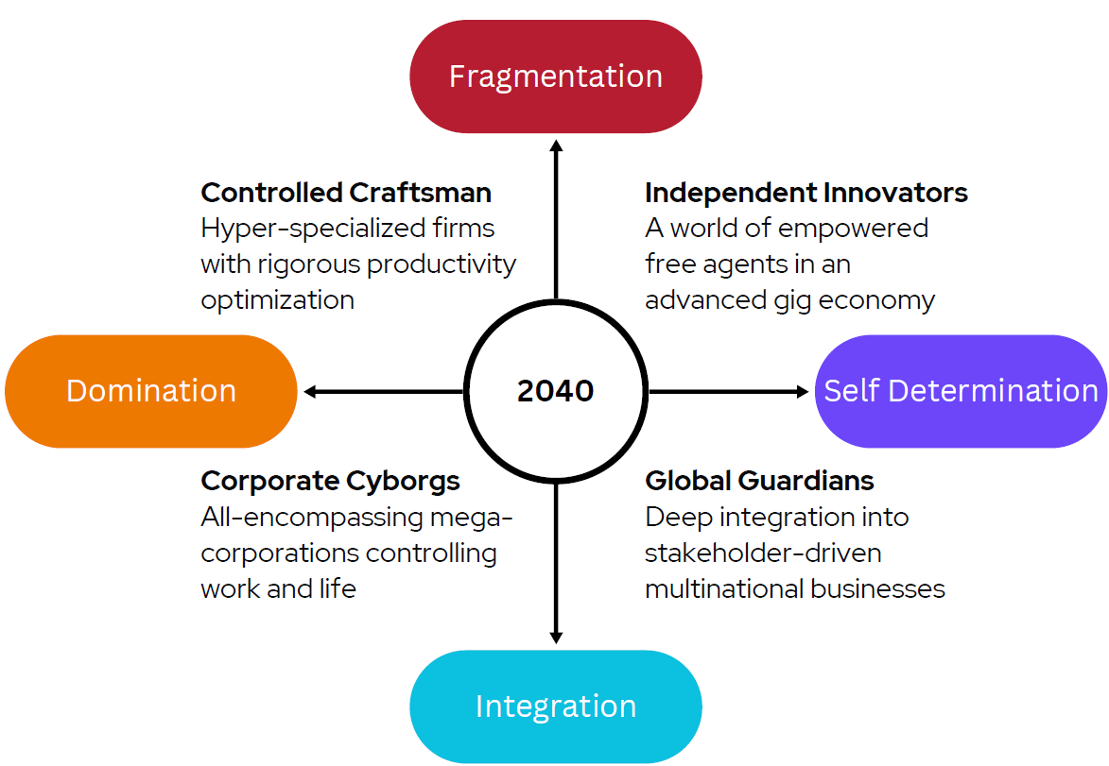
- Independent Innovators, based on fragmentation and self-determination. This scenario envisions a decentralized economy driven by gig workers and freelance platforms, where individuals have greater autonomy but experience a lack of social protection.
- Controlled Craftsmen, based on fragmentation and domination. In this scenario, small, specialized businesses dominate, with workers monitored closely and operating under intense pressure for productivity. Mental health concerns and eroded worker rights are key challenges.
- Corporate Cyborgs, based on integration and domination. In this scenario, a few powerful corporations control both life and work, prioritizing efficiency at the cost of worker autonomy. Job security is high, but individual freedom and creativity are restricted.
- Global Guardians, based on integration and self-determination. This scenario envisions deep integration into the global economy, with corporations driven by ethical governance and sustainability. Workers enjoy a structured, supportive environment but face challenges from corporate influence over public institutions.
It is noteworthy that scenarios outline a narrative of what might happen, and effective scenarios are not evaluated by whether they ultimately materialize. In general, every scenario is built on what already exists today, and highlights and emphasizes certain characteristics, but some elements don't exist in our current local reality (but may already exist in other countries). It is also important to mention that these types of transformation do not occur in one day, which is why the scenarios paper includes a timeline, outlining smaller shifts over time that eventually would lead to these transformations.
In each scenario, we attempted to address the following questions:
- Who are the winners and losers of the scenario? Who would benefit from its characteristics, and who wouldn't succeed in adjusting?
- What is the role of the government in this scenario?
- How would everyday life be in this scenario? (particularly, how would work-life balance be?)
- What is the role of trade unions in this scenario?
- What are the education and skills required in the world of work in this scenario?
- Regarding innovation and entrepreneurship, who would be the entrepreneurs in this scenario?

Future of Work and Transformation of Today: Insights from the Funding Program Transformation at the HBS by Dr. Manuela Maschke, Hans-Böckler-Foundation
The work of the funding program is at the factory level and focuses on issues concerning workers and work councils, and how they would benefit from research. The Hans-Böckler-Foundation influences mostly through workers' organizations and work councils, including in the private sector, and seeks specific solutions.
The funding program promotes research, which in turn promotes co-determination by finding procedures for workers' participation that succeed in certain companies and implementing them in others. Thus, the funding program integrates the workforce's experience and academic knowledge to promote processes at the factory level.
The presentation included examples of seven projects (originally nine, but due to a shortage of time, only seven were presented) executed by the program, which relate to the four scenarios found in the current study.
The First Project
This project sought to determine whether the workplace is still a social place and to find the consequences of hybrid work. This project began recently and is expected to be completed in February 2026. There are concerns that hybrid work will have a negative effect on cooperation in society; therefore, the project begins with two questions:
- In the long term, will hybrid work reduce communication between workers?
- In the long term, will hybrid work undermine efficiency and innovation?
Hybrid work has reshaped employee expectations, making many reluctant to return to full-time on-site work.
This project relates to the scenarios of Independent Innovations and Controlled Craftsmen, but since the future is uncertain, decisions that are made today and will be made in the future might lead to different scenarios.
The Second Project – Transformations at the Heller
In Heller, a German manufacturing company, there have been layoffs that are expected to continue in the near future. In this company, a new CEO has shifted Heller's strategy to global manufacturing and found a new investor. During this transformation, there was a debate regarding the role of work councils in it, and what they can do to give rise to the workers' voice and express their knowledge.
This project brings together trade unions, works councils, and employers at the local level and gathers ideas on how to change the manufacturing process. Several workshops took place in different departments of the company, and relevant plans were structured. In general, business and financial struggles lack co-determination, and this project was an example of broadening co-determination.
This project relates to the scenario of Controlled Craftsmen due to the fragmentation of the labor force, and can also relate to Independent Innovators.
The Third Project – Transformation at the Main-Rhön
This project examines the strategic trajectory of industrial regions. In the Main-Rhön area, four global manufacturing companies operate. These companies implemented cost-reduction plans, in which innovative budgets are experiencing reductions. These decisions are made at the central level, and not by the local management. The project has brought the workers in the area closer together, found factors contributing to the success of local policies, and developed a regional network. In this project, the collaboration extended beyond trade unions and works councils to include local political actors as well.
This project, due to the involvement of the regional corporations, relates to the scenario of Global Guardians, but in the future, it might relate to the scenario of Corporate Cyborgs.
The Forth Project – Bayer Company
The management of the Bayer company went through a process of decentralization, in which the decision-making process was gradually transferred to the various teams. This process raises the question: who wins and who loses from decentralization? A question that constituted the starting point for this project.
In this project, interviews were conducted with workers in different classes and positions in the company this year, and follow-up interviews will take place next year. This project relates to the scenario of Global Guardians since Bayer is a global company, and is also associated with self-determination and integration, but in the future, it might relate to the scenario of Corporate Cyborgs.
The Fifth Project – EnAIble
In this scenario, AI is a key technology. This project is concerned with the working conditions of workers with disabilities, and an example of a company that employs employees with disabilities was presented. Their work at the company includes inserting a specific number of screws into a plastic bag, and a new AI technology will soon enable them to perform quality control of their work independently. This AI technology raises a question: will there be any work for disabled people in the future?
Here, the connection to a specific scenario is less clear, and maybe the question that should be asked is what scenario will help disabled people to remain employed in the future?
The Sixth Project – Come to Stay
This project deals with work immigrants and seeks an adequate framework for the integration of immigrant nurses in the hospitals, which will enhance the probability that they will stay and not emigrate after a short period of time. This is a complicated issue – the new nurses need to go through an orientation and training period with the more senior staff, but they do not necessarily speak the local language yet, which burdens this period. The question raised by this project is what the role of social services will be in the future, and who will take care of them?
The Seventh Project -Democracy in Action
This project deals with the gaps between companies that practice co-determination and companies that do not. It is important to find ways to perform this transition, from no practical co-determination to the existence and practice of co-determination, and to learn from it. Bottom line, it is important to combine experiences at the plant level and the political dialogue. Furthermore, the elections for the German works councils will be held next year, in which workers without a German passport could participate and vote as well. In fact, this will be the only opportunity for workers without a German passport to elect and be elected – an opportunity that demonstrates that integration is expressed through work.
Dr. Maschke's presentation reflects an important question: how are the scenarios translated into concrete change and decision-making? The projects presented show that it is possible. The conclusion is that changes require someone who cares, on the workers' side – the trade union, and on the employers' side – institutions like the Manufacturers' Association, and for both sides, the government as well.

The Future of the Labor Market in a Digital Era, by Dr. Roby Nathanson, General Director of the Macro Center for Political Economics
The Gig Economy – the Macro Center for Political Economics conducted pioneering research on the Gig Economy, before this issue existed in the public debate. The research included a survey, which was conducted among Israelis and attempted to understand the platforms' significance, both for employees and employers. The study found that platform employment is rather complementary, and not employees' main source of income. During COVID-19, working from home became more significant, which gave rise to broader employment via platforms.
Digitalization and the use of platforms challenge labor relations and the defined relations between employers to employees; instead, invisible powers organize these relations. The Macro Center's study was presented to decision makers and relevant stakeholders at the Knesset, and a decision was made to establish a committee to adjust labor relations to the new reality.
The gig economy plays a central role in shaping patterns of self-employment and freelance work. In the past, labor agreements were significant and included all workers, but due to criticism calling them out as too rigid and needing to be more flexible, there were attempts to make labor relations more flexible, such as manpower companies, and later on, personal agreements.
The issue of freelance employment: freelancers are individuals who provide services to a company, and the company pays them according to invoices they issue, and they are responsible for deducting payments for National Security and other taxes. This employment model expanded significantly during the COVID-19 pandemic and has continued to grow since, and has become even more viable with the digitalization of the labor market. These workers are often called Hybrid wage earners, reflecting that they work as regular wage earners, but also work through the platforms.
The public conception is that the self-employed choose this type of employment, but that is not exactly accurate – the labor market, attempting the make working conditions more flexible, pushes the workers to choose the path of self-employment. The self-employed are not entitled to various social protections, most of them earn less than the average salaries in their field of work, and often do not hire employees. Due to these challenges, the self-employed and freelancers' forum was established, and it allows the self-employed to become trade union members, even without working in a workplace included in a collective agreement, and receive all benefits offered to the Histadrut members.
From a future perspective, considering all the digital changes, survey findings indicate that most workers prefer salaried employment, included in collective agreements, and to receive social protection, rather than being self-employed and enjoying the freedom to choose. This is a possible explanation for the steady rate of self-employment over the years in Israel and some other OECD countries, as well as for the trend of growth in the rate of hybrid wage earners.
Strategic Long-Term Planning of the Labor Market – Discussion Panel
Remarks by Prof. Bettina Kohlrausch, Hans-Böckler-Foundation
Prof. Kohlrausch's remarks represent the European perspective. In the context of scenarios and future challenges, uncertainties constitute a breeding ground for anti-democratic attitudes and voting preferences for far-right parties. People who worry more about changes, and it was found that almost half of the workers are worried about changes, are more likely to have anti-democratic attitudes. People with low incomes are more worried about changes, but it also has to do with social recognition and social identity. We must address three main issues:
- Co-determination – it is important to strengthen co-determination in the work environment. Although people aspire to work as wage-earning employees, they want more autonomy, which is not easy to fulfill, but co-determination can assist with that through the unionization of workers.
- Regulation – even in Europe, the social security system is adjusted more towards traditional employment rather than self or hybrid employment, and we need to think of ways to protect these kinds of flexible employment. There is a debate regarding ensuring a minimum income, which will provide security in uncertain periods.
- Education and training – training is a tool to strengthen workers' rights. To make better use of this tool, we need to make education more accessible and to ensure that working councils have a say in the training their employees receive.
Remarks by Shay Weinblum, the Arlozorov Forum
The topics underdiscussed are power and control. When discussing self-employment, we don't take into account that the labor market is controlled by big global corporations, and not by independent innovators. The stigma is that young people do not care about social protection, but prefer rewarding working facilities and the ability to move from place to place, and in general, they want flexibility in every possible aspect – but the data does not back that up. Although people don't want to work at the same workplace all their lives, they do want certain security, and this is an issue that the government, employers, and corporations should address.
Over time, work regulations are dissolving or adjusting themselves to the new reality, but they don't always manage to keep up with the rapid changes; therefore, trade unions must adopt a more forward-looking and strategic perspective. The focus should be on the social battle of capital vs. labor. The conclusion is that we need to act now. In this reality, employee-owned corporations are optimal, although less likely in Israel; that is a concept that should be encouraged.
In the context of the October 7th war, the war likely won't have long-term repercussions, but in the current context, in the short term, the situation is that young people who experienced significant employment security, as part of their reserved service, are returning to the job market, which doesn't provide the same security and doesn't necessarily need them.
Remarks by Dan Catarivas, Israel's Manufacturers Association
Dan Catarivas's remarks represent the employers' perspective. The distinctiveness of the Israeli situation can't go unnoticed – long-term strategic planning has not traditionally been embedded in our institutional culture, due to the uncertainty that Israel is characterized by. The labor market, as we know it today, won't be the same in the future; significant demographic shifts in Israel and Europe, especially in the context of age, are affecting the market's dynamics. Israel, being a small country and high-tech-oriented, has its effect on the labor force and employment.
Over the years, there has been a transition from social employment to individual employment, and ups and downs have been experienced in the relations between the trade unions (the Histadrut) and the employers' unions. There were periods when trade unions and employers' unions worked jointly to improve working conditions, for example, in the Second Lebanon War, the Histadrut and employers' unions worked jointly to ensure workers received compensation.
Employers care most about productivity, and in light of the digitalization and other technological breakthroughs, integrating technology in production processes has proven to be productive – it has become possible to produce with fewer workers, which reduces cost to the employers. Although in the Israeli market it is not very problematic, due to labor shortage, which forces employers to upgrade their production processes and introduce more technology. The October 7th war is a good example of that – many workers were absent from the workplace because of their reserved service, but the economy had to continue functioning as usual, which suggests that when facing a labor shortage, employers came up with adequate solutions.
In Israel, structural changes are expected to occur, and the self-employed are expected to lose from these changes. For example, in the short term, the number of self-employed businesses that do not hire employees might be reduced, because the reserved service doesn’t allow these businesses to operate. In some countries, such as China, the Gig Economy has become popular even in the mainstream production industries, but the main challenge with the Gig Economy is that the legal status of these workers is not yet regulated.
Remarks by Itamar Gazala, Ministry of Innovation, Science and Technology
When discussing long-term planning of the labor market, we are discussing innovation. There are a few key points that serve as possible growth engines.
- Technical Education – Providing informal scientific education from a young age due to its significant role in raising productivity.
- Applied Research – Often, research conducted at universities is basic research, but shifting basic research to growth doesn't receive funding; thus, the Ministry of Innovation highlights the importance of applied research by funding it at universities, and emphasizes the importance of international academic cooperation.
- Promoting National Programs, which are decided on by the government, through an advisory committee, and promoting innovation in the private sector and in the government as well. The governmental employees and the government itself must be innovative.
- Strategic Forecasting – The government, and maybe Israelis in general, are not good at long-term planning. A division called "Horizon Scanning" uses big data and AI tools to forecast strategically, and a government thinktank, and plenty of ministries use this division's work to plan. In this division, it is clear that there is no one future; therefore, they try to build Israel's technological resilience to prepare for the future.
In the context of scenarios, they include fields that the Ministry of Innovation and the government attempt to address. For example, taking the scenario of Corporate Cyborgs, the ministries of innovation and law attempt to address issues of AI ethics and regulations, which are complicated, because too much regulation could hinder innovation. Therefore, the attempt is to build a general ethical framework and guidelines. Strengthening applied research is related to the scenario of Controlled Craftsmen, because research scholarships are given to populations from lower socio-economic layers, which can lead to the discovery of more skilled individuals. In the context of the Global Guardians scenario, strengthening international cooperation and sustainability fits this scenario. Dealing with global and environmental issues plays an important role in shaping the labor market, and from the government's point of view, this is the preferable scenario.

Discussion and Questions – Main Topics
- The freedom to choose is one of the most important issues for young people and is an important component of the Gig Economy. Young people want to determine how much they will work, how much they will earn, etc. This freedom does not apply to everyone, and not all workers have the right skills for it.
- The Spanish model, as a way of regulating the status of freelance workers, was mentioned. According to this model, if a freelance worker provides services to a company, and it is the source of at least 75% of his income, the company needs to treat him like a wage-earning employee.
- In the EU, each country's legal system might interpret freelance workers' legal status and policy regarding them differently, making their application difficult.

Concluding Remarks, Dr. Stefan Lücking (HBS) and Dr. Roby Nathanson (Macro Center for Political Economics)
- We should take a closer look at the axes and understand their interrelations. Specifically, the axis of Domination vs. Self-Determination is important in the history of labor movements, and the challenge we experience today is that economies are dependent on corporations with anti-union attitudes.
- In Europe, as well as in Israel, there is a need to regulate technology without hindering innovation. The goal is to create regulations that promote innovation.
- Although different countries, the scenarios help us to compare Israel to Germany and not ignore blind spots.
- The current scenario project is a result of the COVID-19 pandemic, and it was conducted despite facing various challenges. In terms of methodology, over 100 in-depth interviews were conducted with relevant stakeholders. The results were shared with the Hans-Böckler-Foundation and German experts, who provided feedback and suggestions. Based on the stakeholders' insights, we extracted the two axes, which were the ground for the establishment of the four scenarios.
- Current challenges for the future scenarios are the trade war and global decision-making. Today, globalization is less relevant, since each country makes its own decisions.
- Another issue is the AI, which poses challenges to the existence of many professions, but based on our experience, on one hand, in technological transformations, many professions become irrelevant, but on the other hand, many new professions are introduced.
- In the past, the idea was that technology would enable people to experience more leisure, but in reality, what happened was exactly the opposite, as can be seen in long working hours in the High-Tech industry. The conclusion is that sometimes conception has nothing to do with the actual reality, and it is something that we can take into consideration when thinking about future scenarios.

